EmbedUR ASSIGNMENT- 1 ADVANCED C PROGRAMMING

G ADITHYA PRASAD

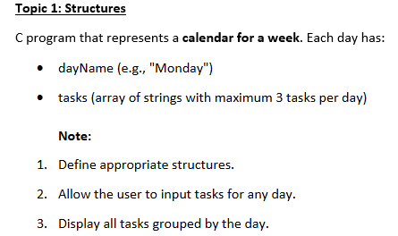
CODE:
#include <stdio.h>

#define DAYS 7
#define MAX_TASKS 3

struct Day
{
char dayName[20];
char tasks[MAX_TASKS][50];
int taskCount;
};

int main()
{
struct Day week[DAYS];

char names[DAYS][20] =
{
"Monday",
"Tuesday",
"Wednesday",
"Thursday",
"Friday",
"Saturday",
"Sunday"
};

// Assign day names
for(int i=0;i<DAYS;i++)
{
strcpy(week[i].dayName, names[i]);
week[i].taskCount = 0;
}

// Input tasks
for(int i=0;i<DAYS;i++)
{
printf("\nEnter number of tasks for %s (max 3): ",
week[i].dayName);

scanf("%d",&week[i].taskCount);

if(week[i].taskCount > 3)
week[i].taskCount = 3;

for(int j=0;j<week[i].taskCount;j++)
{
printf("Enter Task %d: ",j+1);
scanf("%s",week[i].tasks[j]);
}
}

// Display
printf("\n\n===== WEEKLY CALENDAR =====\n");

for(int i=0;i<DAYS;i++)
{
printf("\n%s:\n",week[i].dayName);

for(int j=0;j<week[i].taskCount;j++)
{
printf("%d. %s\n",
j+1,
week[i].tasks[j]);
}
}

return 0;
}

Concept Used: Structures
A structure in C is a user-defined data type that allows multiple variables of different data types to be grouped together under a single name.

Structure Definition
struct Day
{
char dayName[20];
char tasks[3][50];
int taskCount;
};

Explanation
The structure Day contains three members:
- dayName
  - Stores the name of the day.
  - Example: Monday, Tuesday, etc.
- tasks
  - A two-dimensional character array.
  - Can store a maximum of 3 tasks.
  - Each task can contain up to 50 characters.
- taskCount
  - Stores the number of tasks assigned to a particular day.

Program Logic
The program follows the steps below:

Step 1: Create an Array of Structures
struct Day week[7];
An array of seven structures is created to represent the seven days of the week.

Step 2: Initialize Day Names
A separate array is used to store the names of all seven days.
char names[7][20] =
{
"Monday",
"Tuesday",
"Wednesday",
"Thursday",
"Friday",
"Saturday",
"Sunday"
};
The names are copied into each structure using the strcpy() function.
strcpy(week[i].dayName, names[i]);
This assigns the correct day name to each element of the structure array.

Step 3: Input Number of Tasks
For every day, the user is asked to enter the number of tasks.
scanf("%d", &week[i].taskCount);
Since the maximum number of tasks allowed is three, the program checks the limit.
if(week[i].taskCount > 3)
week[i].taskCount = 3;
This prevents the user from entering more than three tasks.

Step 4: Input Tasks
A loop is used to enter tasks for each day.
for(int j=0; j<week[i].taskCount; j++)
{
scanf("%s", week[i].tasks[j]);
}
Each task entered by the user is stored in the corresponding position of the task array.
Example:
Task 1: Study
Task 2: Gym
Task 3: Project
These values are stored as:
tasks[0] = "Study"
tasks[1] = "Gym"
tasks[2] = "Project"

Step 5: Display Weekly Calendar
After storing all tasks, the program displays the calendar.
for(int i=0; i<7; i++)
{
printf("%s\n", week[i].dayName);
}
For each day, all stored tasks are printed.
for(int j=0; j<week[i].taskCount; j++)
{
printf("%s", week[i].tasks[j]);
}
This groups tasks according to the day on which they were entered.
OUTPUT:

Enter number of tasks for Monday (max 3): 1
Enter Task 1: office

Enter number of tasks for Tuesday (max 3): 2
Enter Task 1: work
Enter Task 2: rest

Enter number of tasks for Wednesday (max 3): 1
Enter Task 1: bicycle

Enter number of tasks for Thursday (max 3): 2
Enter Task 1: office
Enter Task 2: play

Enter number of tasks for Friday (max 3): 2
Enter Task 1: movie
Enter Task 2: office

Enter number of tasks for Saturday (max 3): 1
Enter Task 1: rest

Enter number of tasks for Sunday (max 3): 2
Enter Task 1: rest
Enter Task 2: project
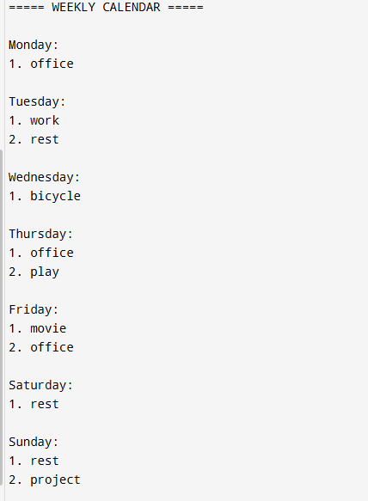

QUE2:

Question
Write a function in C that takes a pointer to an integer array and its size, and rearranges the array such that all even numbers appear before odd numbers while preserving their original relative order. The solution must use only pointer arithmetic and should not use array indexing ([]).
Code:

#include <stdio.h>
#include <stdlib.h>

void rearrange(int *arr, int size)
{
int *temp = (int *)malloc(size * sizeof(int));

int *ptr = arr;
int *t = temp;

/* Copy all even numbers first */
while(ptr < arr + size)
{
if((*ptr % 2) == 0)
{
*t = *ptr;
t++;
}
ptr++;
}

/* Reset pointer */
ptr = arr;

/* Copy all odd numbers */
while(ptr < arr + size)
{
if((*ptr % 2) != 0)
{
*t = *ptr;
t++;
}
ptr++;
}

/* Copy back to original array */
ptr = arr;
t = temp;

while(ptr < arr + size)
{
*ptr = *t;
ptr++;
t++;
}

free(temp);
}

int main()
{
int arr[] = {1, 4, 3, 2, 8, 5};
int size = sizeof(arr) / sizeof(arr[0]);

rearrange(arr, size);

printf("Rearranged Array:\n");

int *p = arr;

while(p < arr + size)
{
printf("%d ", *p);
p++;
}

return 0;
}

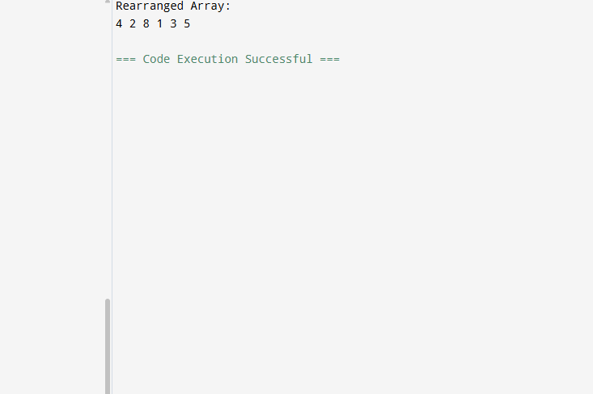

Algorithm
- Create a temporary array of the same size as the original array.
- Traverse the original array using a pointer.
- Copy all even elements into the temporary array.
- Traverse the original array again.
- Copy all odd elements into the temporary array.
- Copy the contents of the temporary array back to the original array.
- Free the dynamically allocated memory.

Program Explanation

Function Declaration
void rearrange(int *arr, int size)
The function accepts:
- arr : Pointer to the first element of the array.
- size : Number of elements present in the array.

Dynamic Memory Allocation
int *temp = (int *)malloc(size * sizeof(int));
A temporary array is dynamically created to store the rearranged elements.

Pointer Initialization
int *ptr = arr;
int *t = temp;
- ptr is used to traverse the original array.
- t is used to traverse the temporary array.

Copying Even Numbers
The first traversal checks every element.
if((*ptr % 2) == 0)
If the element is even, it is copied to the temporary array.
For the input:
1 4 3 2 8 5
The temporary array becomes:
4 2 8

Copying Odd Numbers
The pointer is reset to the beginning of the original array.
ptr = arr;
The second traversal copies all odd numbers.
The temporary array finally becomes:
4 2 8 1 3 5

Copying Back to Original Array
The contents of the temporary array are copied back into the original array.
*ptr = *t;
After copying, the original array contains:
4 2 8 1 3 5

Memory Deallocation
free(temp);
The dynamically allocated memory is released to avoid memory leaks.

Time Complexity
The array is traversed three times:
- First traversal for even numbers → O(n)
- Second traversal for odd numbers → O(n)
- Third traversal for copying back → O(n)
Overall Time Complexity: O(n)

Space Complexity
A temporary array of size n is used.
Space Complexity: O(n)

QUE 3: Question
You are given a 2D matrix of size n × n where each row and each column is sorted in increasing order. Write a C function to determine whether a given key exists in the matrix using the most efficient approach.
Code:
#include <stdio.h>

int search(int n, int matrix[n][n], int key)
{
int row = 0;
int col = n - 1;

while(row < n && col >= 0)
{
if(matrix[row][col] == key)
return 1;

else if(key < matrix[row][col])
col--;

else
row++;
}

return 0;
}

int main()
{
int n, key;

printf("Enter size of matrix: ");
scanf("%d", &n);

int matrix[n][n];

printf("Enter matrix elements:\n");

for(int i = 0; i < n; i++)
{
for(int j = 0; j < n; j++)
{
scanf("%d", &matrix[i][j]);
}
}

printf("Enter key to search: ");
scanf("%d", &key);

if(search(n, matrix, key))
printf("Element Found\n");
else
printf("Element Not Found\n");

return 0;
}

Program Explanation
The matrix is sorted in two ways:
- Each row is sorted from left to right.
- Each column is sorted from top to bottom.
Because of this property, we can efficiently eliminate rows or columns during the search.
The search begins at the top-right corner.

Case 1: Element Found
If the current element is equal to the key, the search stops immediately.

Case 2: Key is Smaller
If the key is smaller than the current element, move left because all elements below the current element are larger.

Case 3: Key is Larger
If the key is larger than the current element, move down because all elements to the left are smaller.
This process continues until the key is found or the search goes outside the matrix.

Dry Run
Consider the matrix:
1 4 7 11
2 5 8 12
3 6 9 16
10 13 14 17
Let the key be 8.
Step 1:
Current Element = 11
Since 8 < 11, move left.
Step 2:
Current Element = 7
Since 8 > 7, move down.
Step 3:
Current Element = 8
Since 8 = 8, the element is found.

Time Complexity
At every step, one row or one column is eliminated.
Therefore:
Time Complexity = O(n)

Space Complexity
Only two variables (row and column) are used.
Therefore:
Space Complexity = O(1)
